ST. XAVIER’S COLLEGE
Maitighar, Kathmandu


A Mini Project On
“Web-Based School Management System”

Under the supervision of
“Jaya Sundar Shilpakar”
Lecturer
Department of Computer Science

Submitted By:
“Anup Ghimire” (“824”)

Submitted To:
ST. XAVIER’S COLLEGE
Department of Computer Science Maitighar, Kathmandu, Nepal
“January 25, 2026”

Acknowledgement
The final outcome of this project required a lot of guidance and assistance from a number of people and I am extremely fortunate to receive such proper supervision for the completion of the project. Whatever I have done in this project is only due to such instructions and assistance, and I would not forget to thank them. I am indebted to the Department of Computer Science, St. Xavier's College, Maitighar, for providing me with such an expressive platform for the project. I am heartily grateful to the project supervisor and our respected lecturer Jaya Sundar Shilpakar.
I am thankful and fortunate enough to get constant encouragement, support, and guidance from them, who have helped me in finalizing my project work. I also thank all the organizations and online resources that provided necessary information for this report.
Lastly, I thank all my friends, especially my close friend Anmol Nepal, and my parents for their tremendous contributions and support both morally and financially towards the completion of this project.

Abstract

This project proposal presents a plan to develop a Web-Based School Management System using PHP and MySQL. The system is designed to provide a simple and efficient way to manage basic school-related information such as student records, notices, examination results, and fee details. The system will allow school administrators to easily add, view, update, and delete records, and will provide a user-friendly interface for visitors to access basic information about the school. The project aims to demonstrate the practical application of web technologies learned in the curriculum, including HTML, CSS, Javascript, PHP, and MySQL, and to create a reliable, well-organized, and interactive demo system suitable for a school environment. Additionally, the project will help in understanding real-world challenges in web application development, including database management, form handling, and data security considerations.

Table of contents
Acknowledgement ii
Abstract iii
Table of contents iv
Introduction 1
Problem statement 3
Objectives 4
Methodology 5
Expected outcomes 6
Conclusion 7
References 8

Introduction
In today’s educational environment, schools require efficient and organized systems to manage academic and administrative information. Traditional paper-based methods of record-keeping are often slow, prone to errors, and difficult to maintain. A web-based school management system provides a centralized platform that allows administrators to manage student records, notices, examination results, and fee information more effectively and efficiently. The proposed system uses PHP for server-side processing, MySQL for database management, and HTML and CSS for the frontend interface, offering a user-friendly interface for administrators and visitors.
The concept of school management systems has evolved significantly over the last two decades. Initially, schools relied on manual registers and spreadsheets, which were time-consuming and error-prone. With the growth of web technologies, schools worldwide began adopting web-based school management systems in the early 2000s. In Nepal, the adoption of such systems began around the late 2000s, particularly in urban schools and colleges. [1] Many private schools in cities like Kathmandu and Pokhara introduced web-based portals to manage student admissions, fees, and results online. Well-known systems used in Nepal include EduSec, SmartEdu, and SchoolNet. [2]
The benefits of web-based school management systems are significant:
- Centralized Data Management – All student and administrative data is stored in a single database, reducing redundancy and errors.
- Time Efficiency – Administrative tasks like, fee calculation, and report generation become faster and easier. [3]
- Easy Access – Authorized users can access data anytime and anywhere through a web browser.
- Improved Accuracy – Automated calculations reduce human errors in results and fee management.
- Cost-Effective – Reduces the need for paperwork, printing, and manual storage systems.
- Enhanced Communication – Parents can monitor student performance, and fees online, improving transparency. [4]
The impact of web-based school management systems in Nepal has been notable. Schools can handle large numbers of students efficiently, saving staff time for teaching-related activities. Students and staff develop better digital literacy, while parents gain more transparency regarding student progress. Digital storage ensures data security and reduces the risk of loss. Additionally, these systems help schools and educational authorities collect reports and statistics for better planning and policy implementation. While urban schools have widely adopted these systems, rural schools are gradually moving toward digital solutions with the expansion of internet access and government digital education initiatives. [5]
Overall, the web-based school management system provides a reliable, centralized, and user-friendly platform for managing school information, demonstrating the practical application of web technologies and preparing schools for a more digital and efficient educational environment.
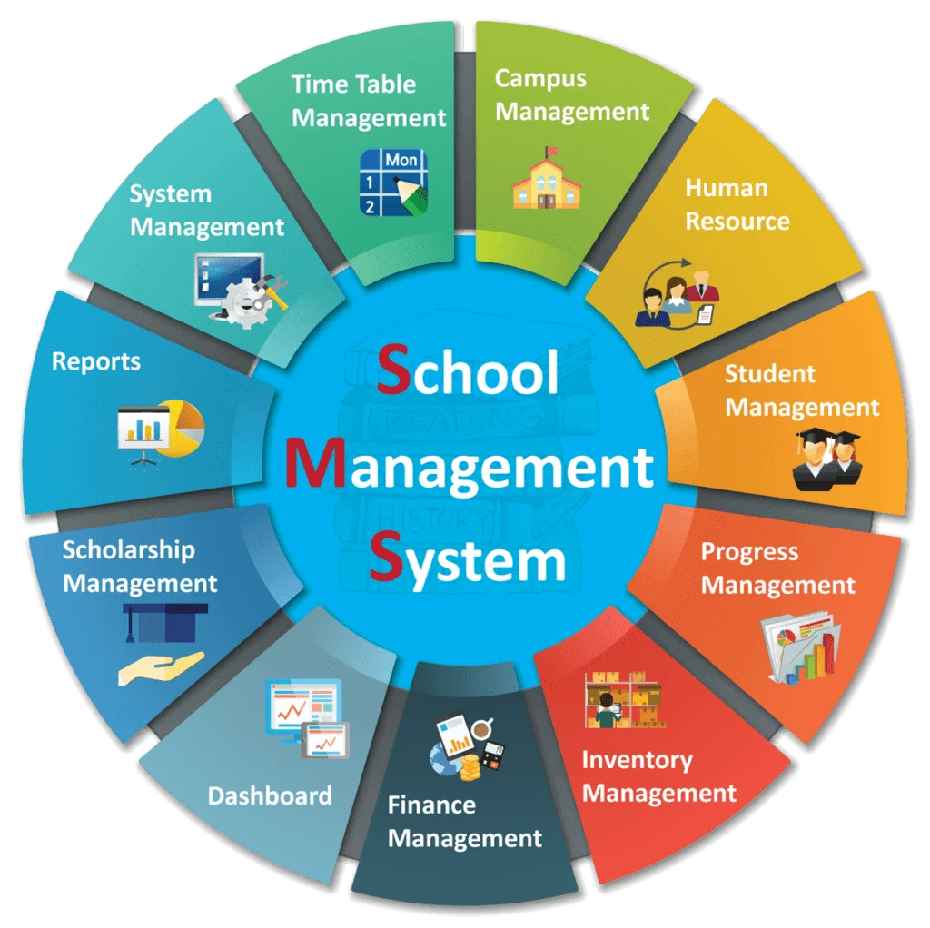

Problem statement
In most schools, administrative and academic tasks are still managed using manual methods such as paper registers, spreadsheets, and notice boards. These traditional methods are time-consuming, prone to errors, and difficult to maintain, especially when managing large numbers of students, teachers, and classes. Issues like lost records, miscalculated results, delayed notices, and inefficient fee management are common.
There is a need for a centralized, digital solution that allows school administrators to manage student records, examination results, notices, and fee details efficiently and accurately. A web-based school management system provides an effective solution by enabling easy access to information, automating routine administrative tasks, and improving communication between school staff, students, and parents.
This project aims to develop a web-based school management system that addresses these challenges by providing a user-friendly, reliable, and centralized platform suitable for managing basic school operations digitally.

Objectives
- To develop a web-based school management system for efficient academic and administrative management.
- To store and manage student records including personal details, class, and section information.
- To manage school notices and announcements for students, parents, and staff.
- To record and display examination results for each student accurately.
- To manage basic fee details including payments, pending fees, and fee reports.
- To provide a user-friendly interface for administrators and visitors to access relevant information easily.
- To demonstrate the practical application of PHP, MySQL, HTML, and CSS in a real-world school scenario.
- To improve efficiency, accuracy, and transparency in school administrative tasks.

Methodology
• Requirement Analysis
- Identify the basic needs of a school for managing students, teachers, classes, notices, examination results, and fees.
- Decide which features will be included in the demo project (student management, notice management, examination & result management, fee management).
• System Design
- Design the database structure using MySQL, including tables for students, teachers, classes, exams, results, and fees.
- Create ER diagrams and flowcharts to visualize data flow and relationships between modules.
- Design user interface layouts for administrators and visitors using HTML and CSS.
• Development
- Implement the frontend using HTML for structure and CSS for styling.
- Use PHP for backend logic to handle data insertion, update, retrieval, and deletion from the database.
- Connect the system to MySQL database to store and manage all records.
- Implement forms for adding/updating student records, entering examination marks, managing notices, and recording fee details.
• Testing
- Test each module separately to ensure it works correctly (unit testing).
- Perform integration testing to check how all modules work together.
- Validate input data and check for errors in calculations, data retrieval, and storage.
• Implementation
- Deploy the system on a local server (like XAMPP) to demonstrate the working demo.
- Verify that all functionalities are accessible and user-friendly for administrators and visitors.
• Documentation
- Prepare proper documentation including database schema, screenshots of system pages, and step-by-step explanation of each module.

Expected outcomes
- A fully functional web-based school management system that demonstrates student, notice, examination, and fee management.
- Centralized management of student and school-related data, reducing manual work and errors.
- Accurate and timely recording of examination results and fee details.
- A user-friendly interface for administrators and visitors, allowing easy access to information.
- Improved efficiency and productivity for school administrative tasks.
- Demonstration of practical skills in PHP, MySQL, HTML, and CSS through a real-world application.
- Enhanced understanding of database management, form handling, and web application development.
- A reliable platform suitable for small-scale adoption in schools, even as a demo for future expansion.

Conclusion
The development of a Web-Based School Management System provides an effective solution to the challenges faced by schools in managing academic and administrative information. By replacing traditional paper-based methods with a centralized digital system, this project demonstrates how student records, notices, examination results, and fee details can be efficiently managed with improved accuracy and transparency. The system not only reduces manual effort but also enhances communication between school staff, students, and parents. Furthermore, it serves as a practical demonstration of web technologies, including PHP, MySQL, HTML, and CSS, applied to real-world scenarios. Overall, this project highlights the importance of digital solutions in modern education, offering a reliable and user-friendly platform that can be expanded in the future to include additional features, making school administration more organized, efficient, and accessible.

References

[1] | "School Management System — WebHouseNepal," [Online]. Available: https://webhousenepal.com/school-management-system?utm_source=chatgpt.com.
[2] | "A Comprehensive History of School Management Systems — NepalSoft (transition to web-based systems)A Comprehensive History of School Management Systems — NepalSoft (transition to web-based systems)," [Online]. Available: https://www.nepalsoft.com.np/news/view/4.
[3] | "Benefits of School Management Systems," [Online]. Available: https://www.hashmicro.com/blog/school-management-system/?utm_source=chatgpt.com.
[4] | "Top 10 Benefits of Implementing a School Management System — BMCoder," [Online]. Available: https://bmcoder.com/blog/top-10-benefits-of-implementing-school-management-software-in-2025.php.
[5] | "School Management System in Nepal," [Online]. Available: https://webhousenepal.com/school-management-system?utm_source=chatgpt.com.

